1. Take 10 integer inputs from the user and store them in an array. Again ask the user to give a number. Now, tell the user whether that number is present in the array or not.

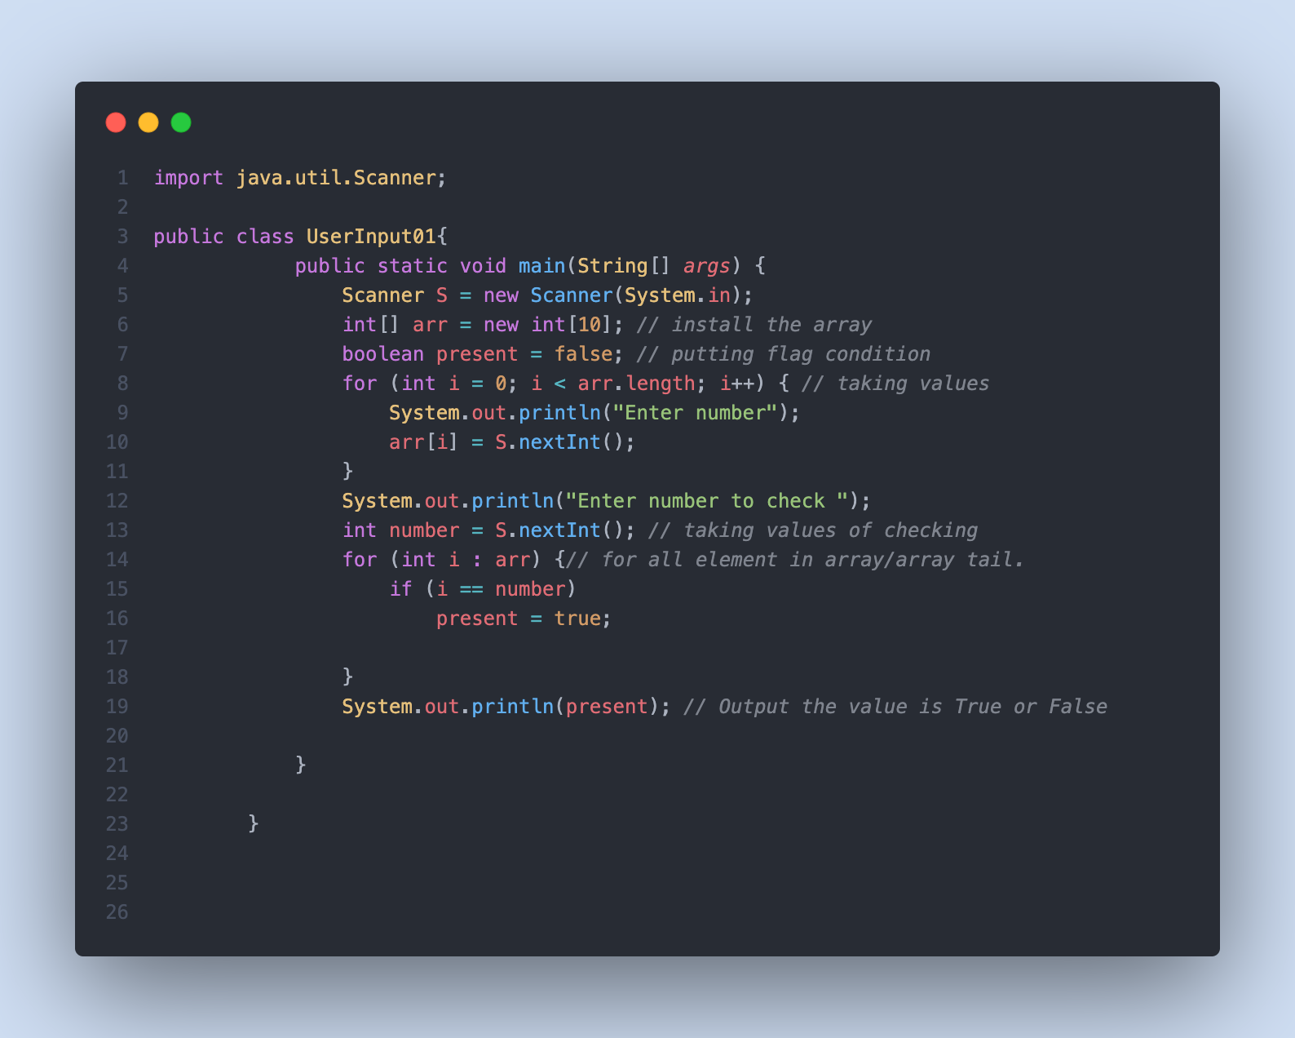

The output for the given program is :

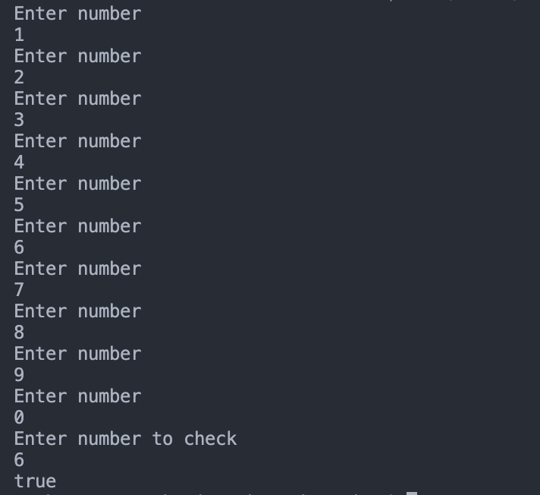

1. Find largest and smallest elements of an array along with the index number of those elements.

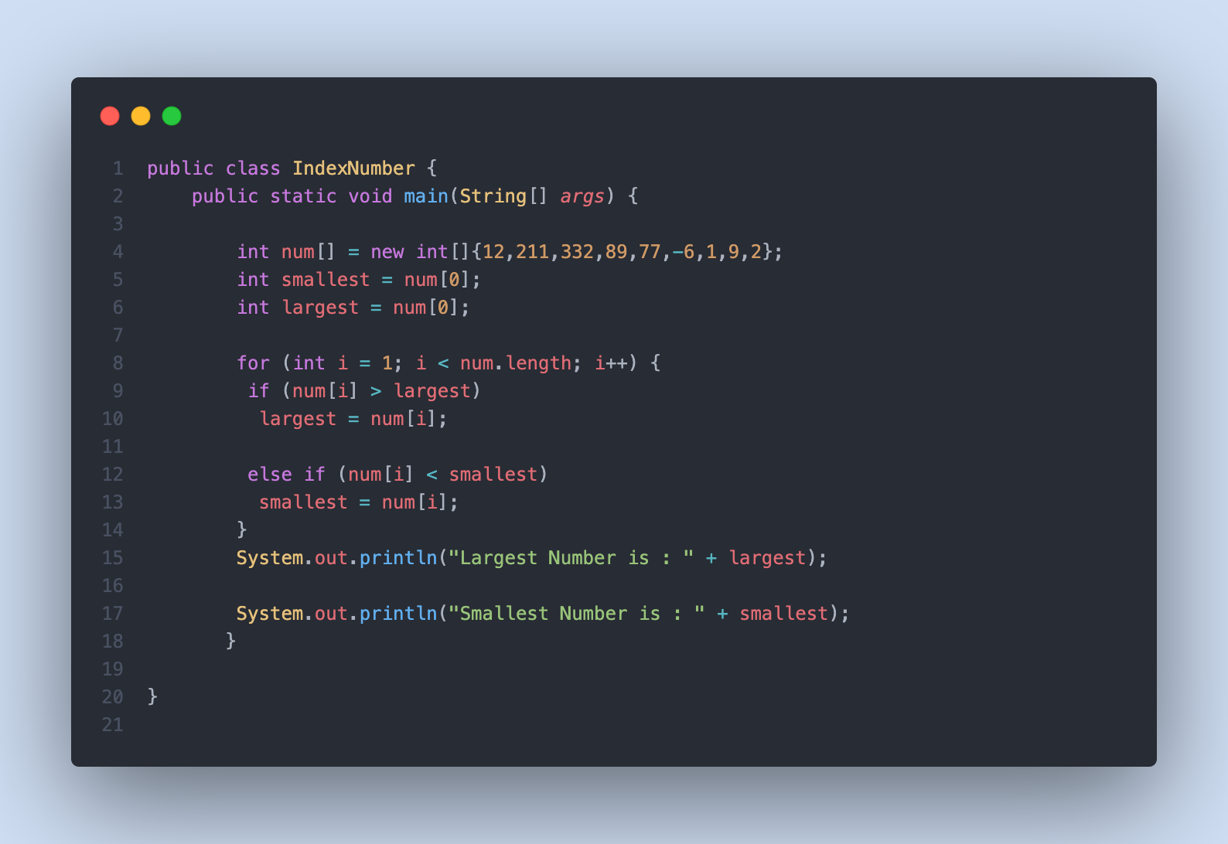

The output for the given program is:

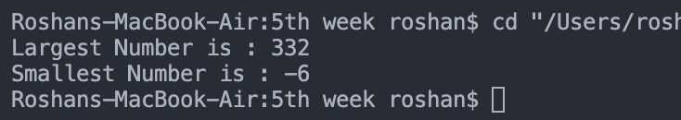

1. If the input array is [10, 12, 20, 30, 25, 40, 32, 31, 35, 50, 60], your program should be able to find that the subarray lies between the indexes 3 and 8.

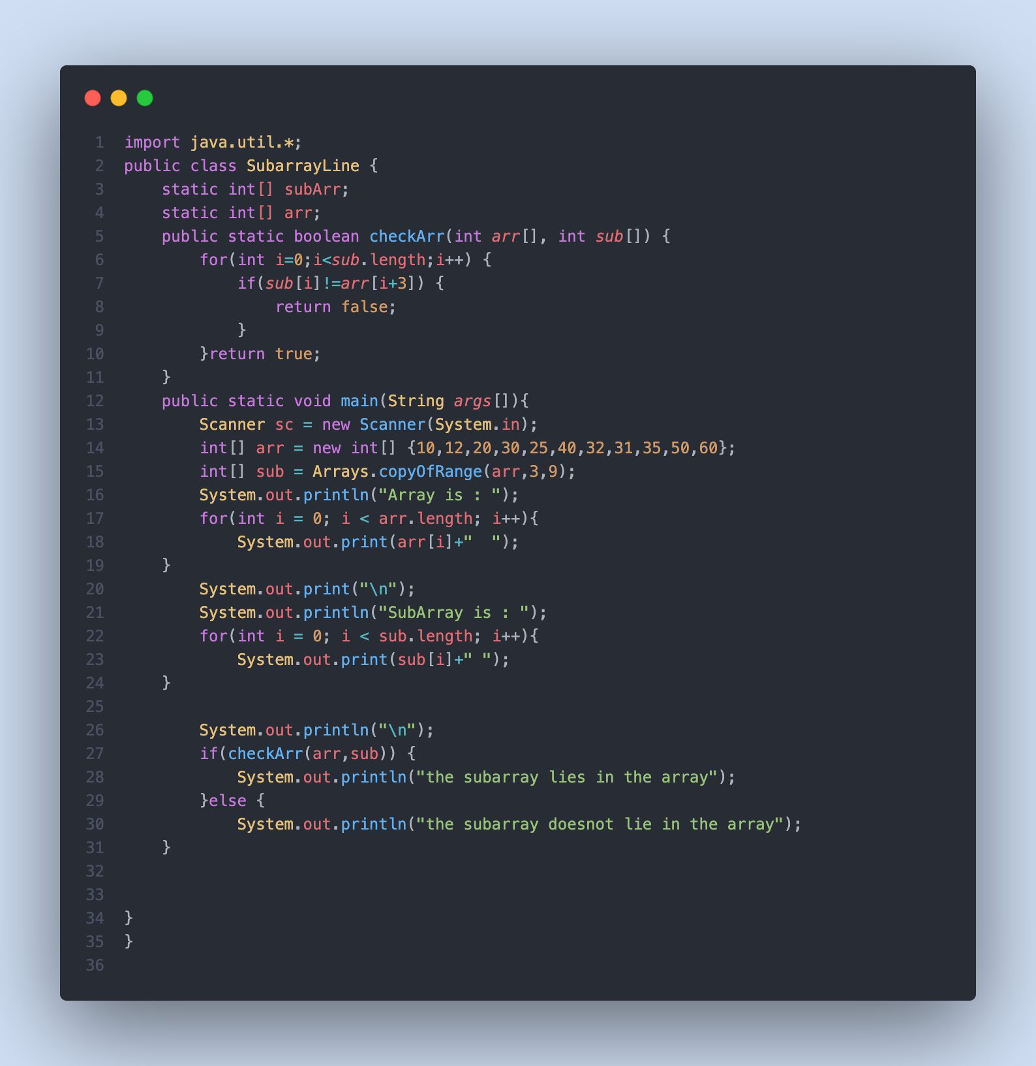

The output for the above program is :

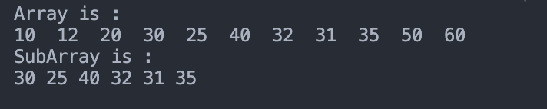

1. Write a program to shift every element of an array to circularly right. E.g.- INPUT : 1 2 3 4 5 OUTPUT : 5 1 2 3 4.

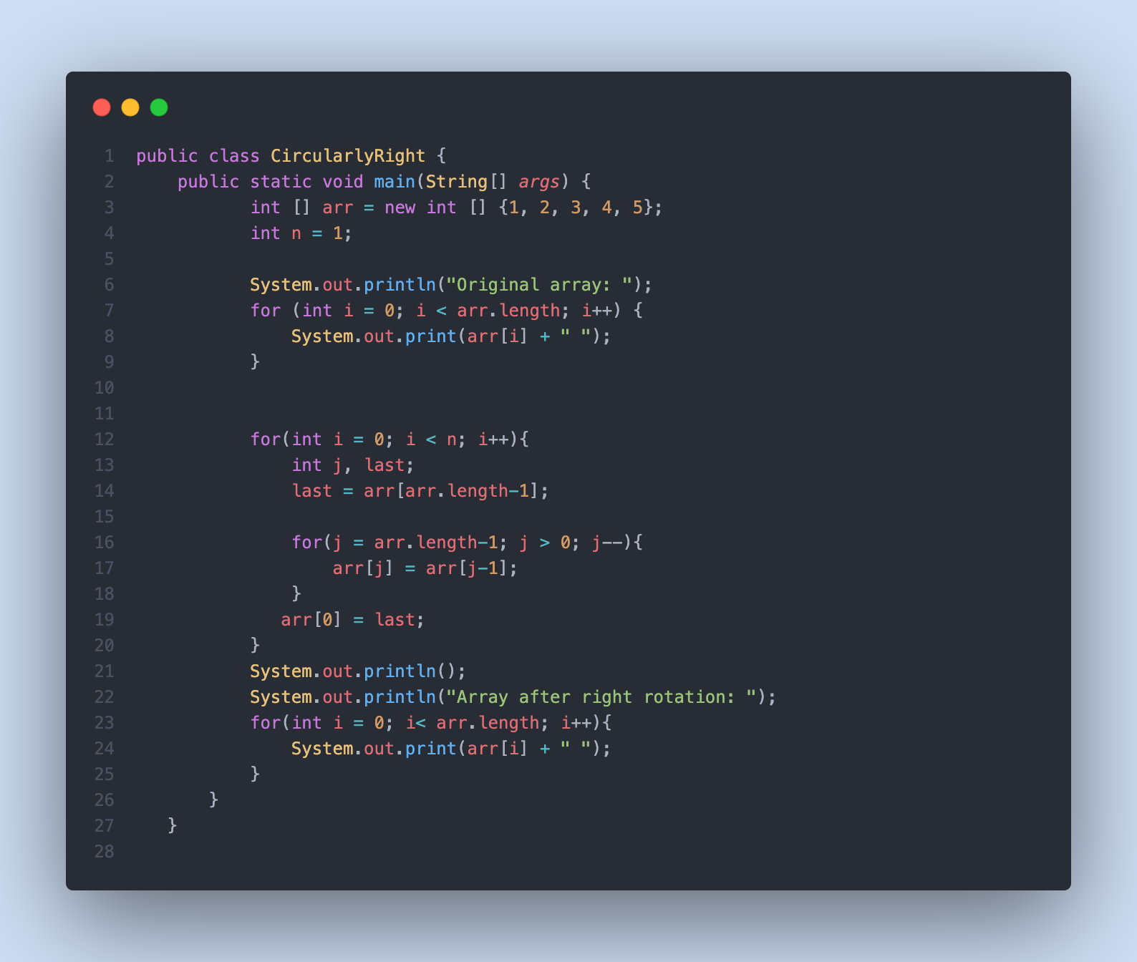

The output for the above program is :

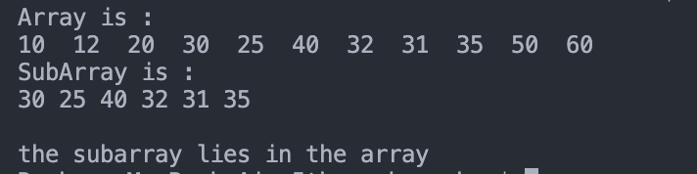

5. Write a java program to sort the elements of an integer array in ascending and descending order.

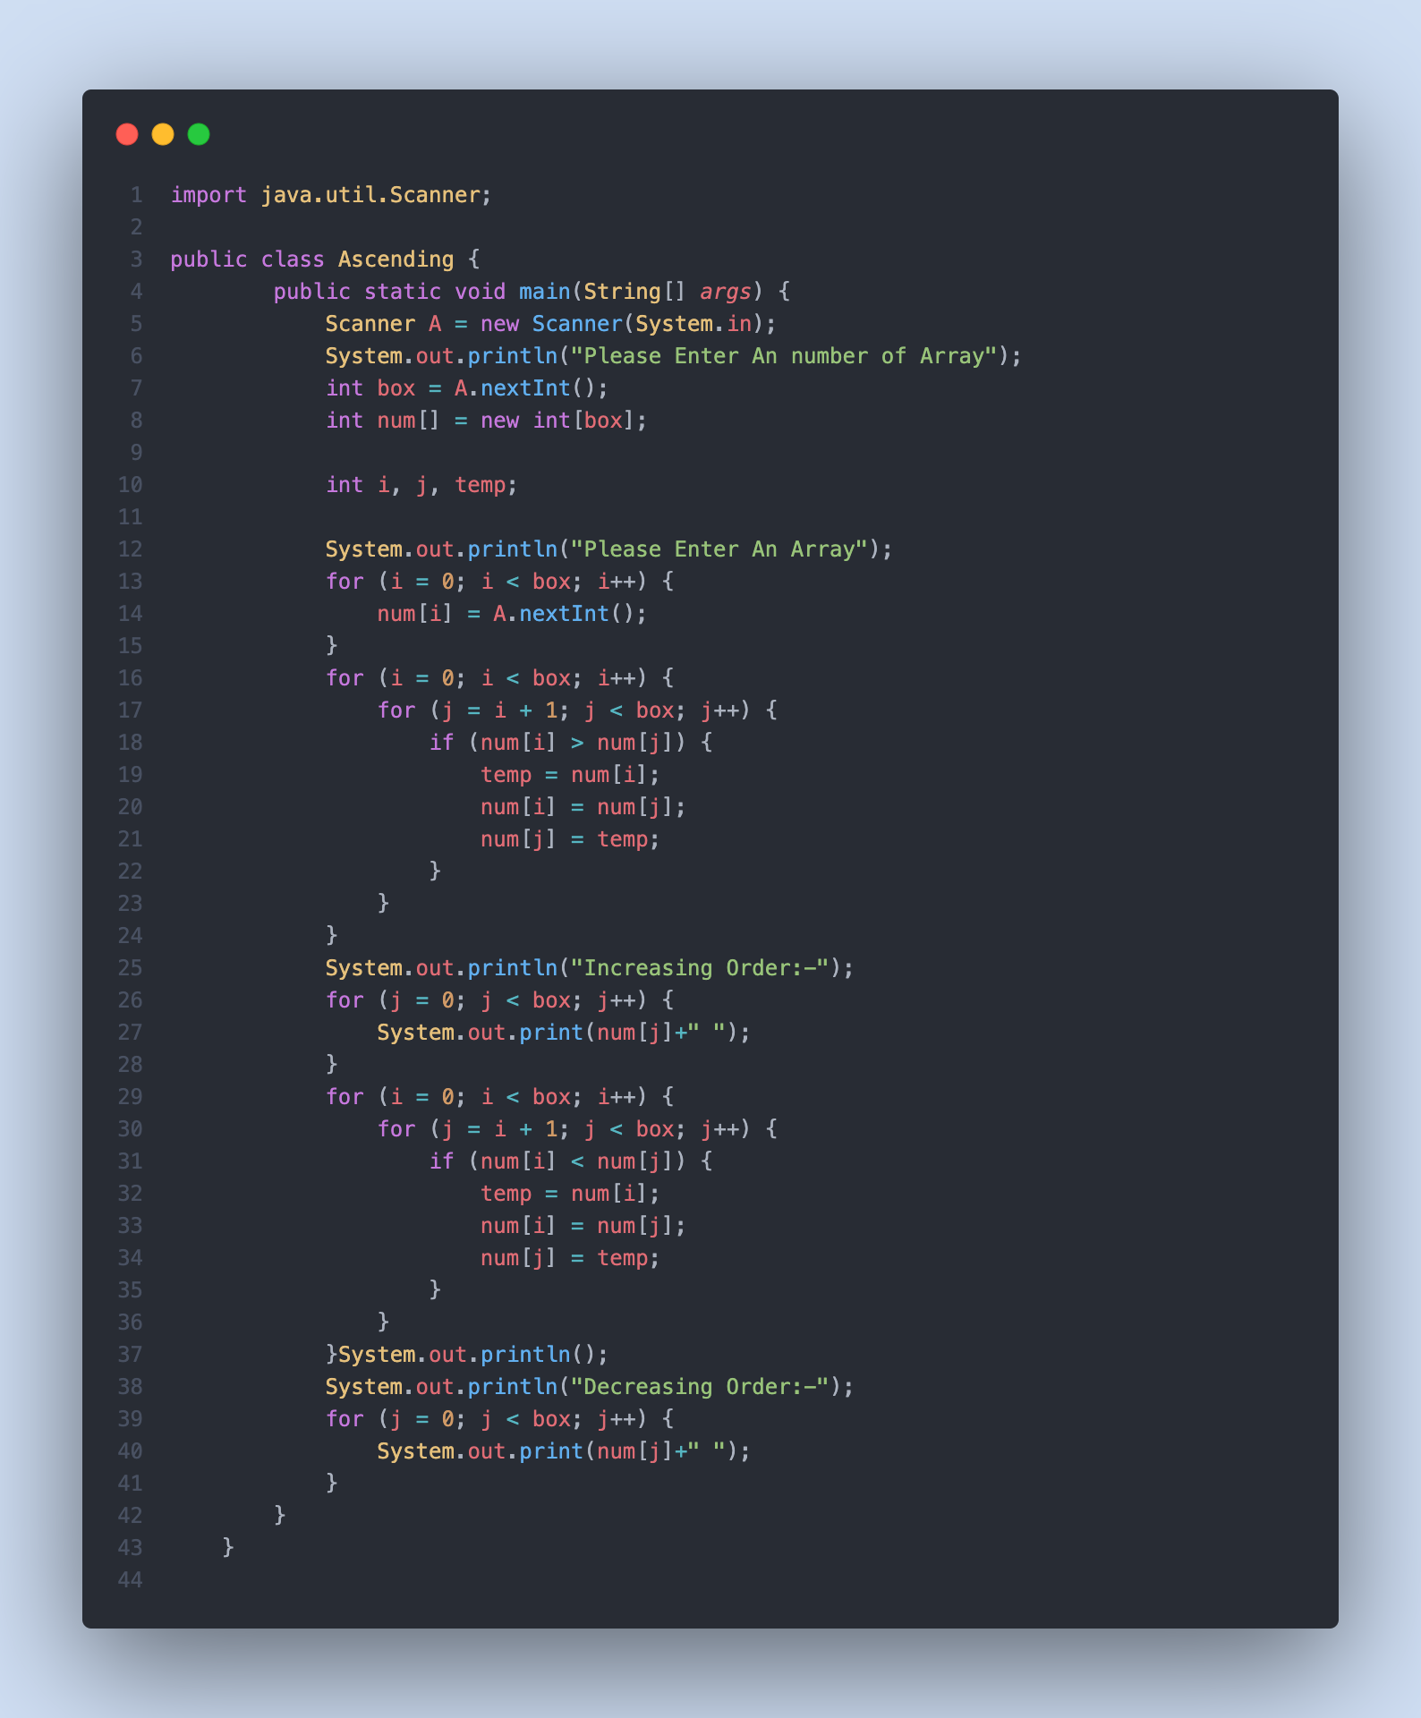

The output for the above program is :

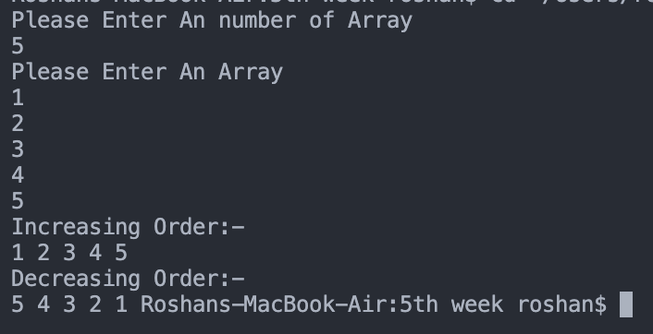

6. Write a java program to print the number of occurrences of each element in an array. Eg. [10,20,30,10,10,20,40] You need to print : 10 occurred 3 times 20 occurred 2 times 30 occurred 1 time 40 occurred 1 time.

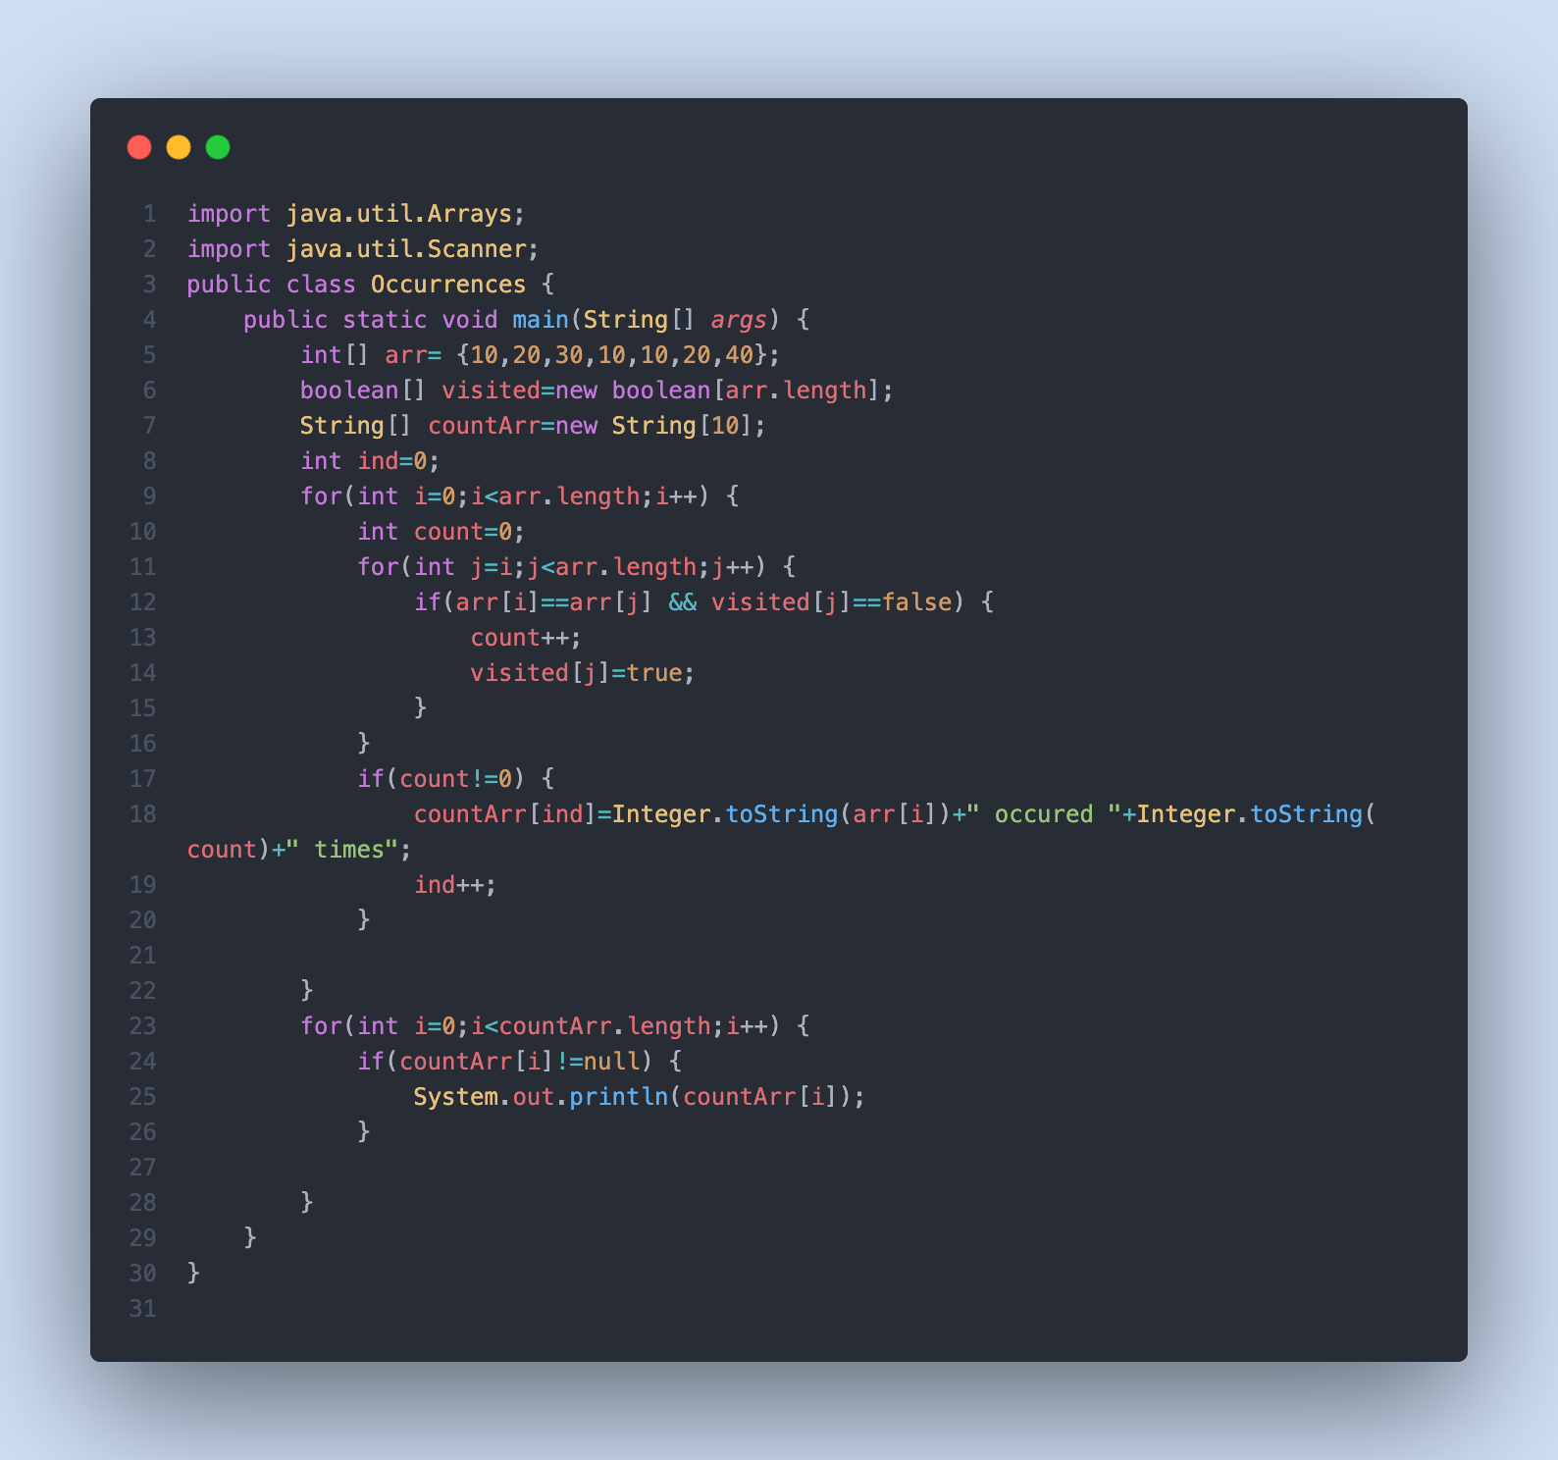

The output for the above program is:

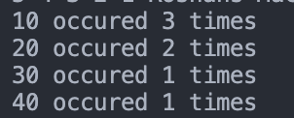

7. Write a Java Program to remove a particular element from an array. Original array : [10,20,30,40,50,60,70] Ask the user to enter the number to delete.Suppose user inputs 50. Delete the number 50 from the array and print the remaining elements as [10,20,30,40,60,70]. If the user inputs the number which is not in the list, print some appropriate message like “Number not in list to delete”.

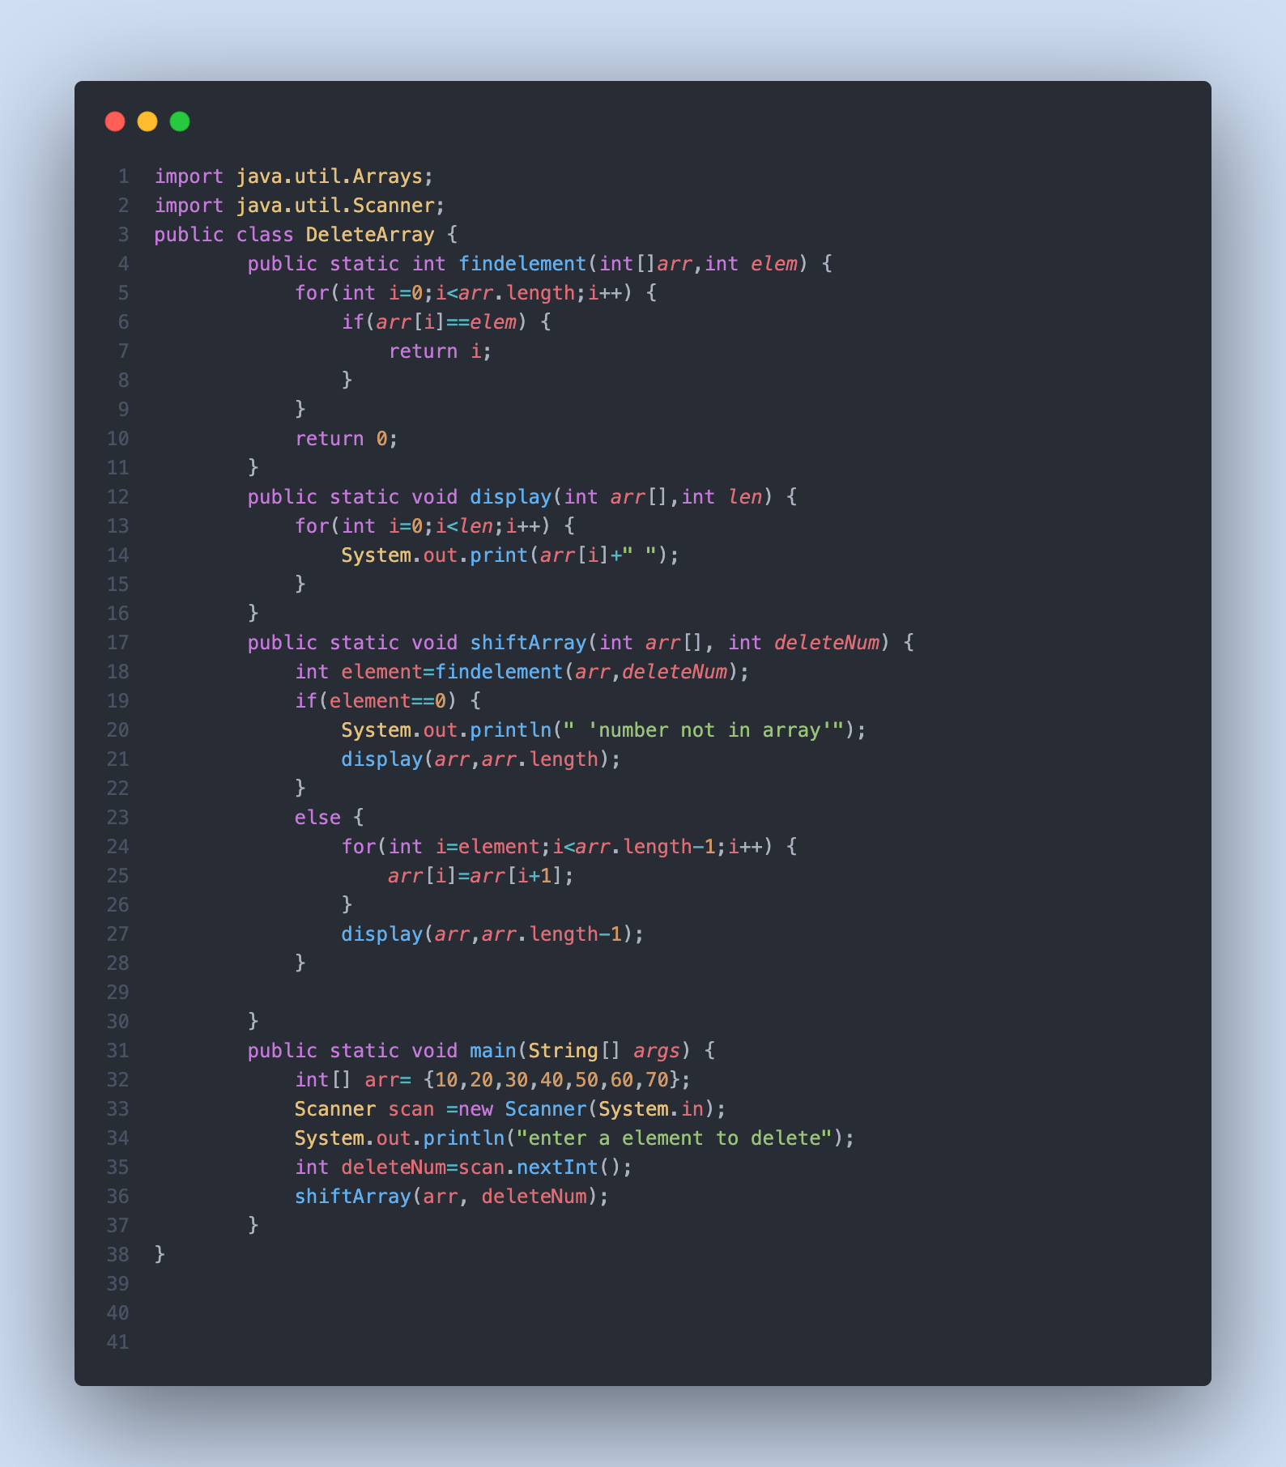

The output for the given program is :

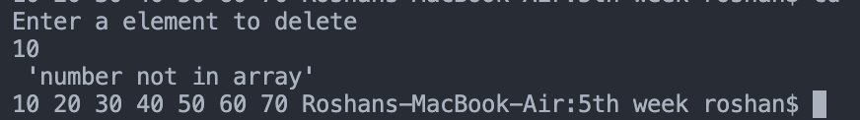

8. Write a Java program to check if two arrays are equal. Equal arrays means both the arrays must have the same elements .

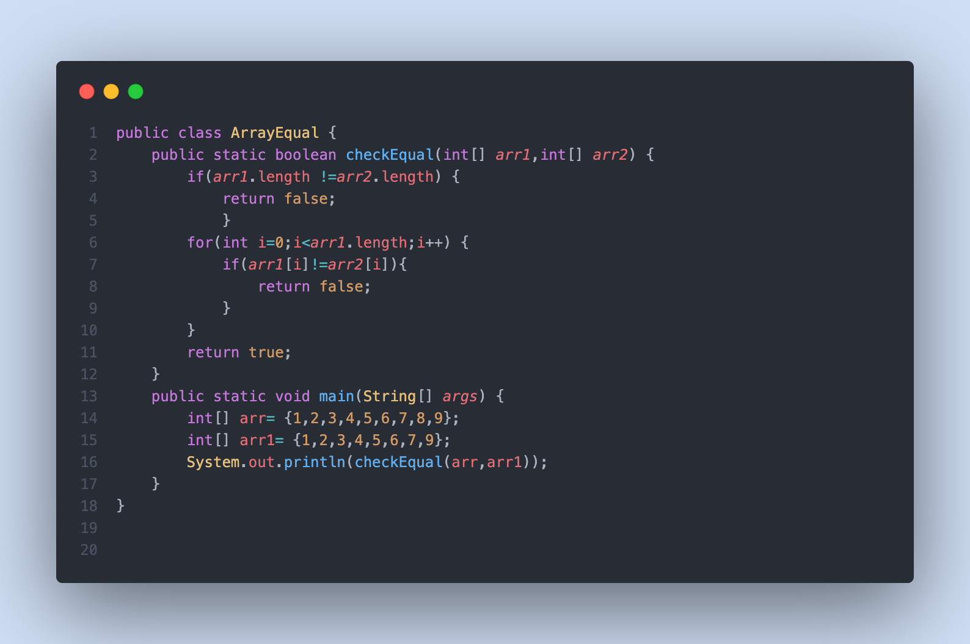

The output for the following program is:

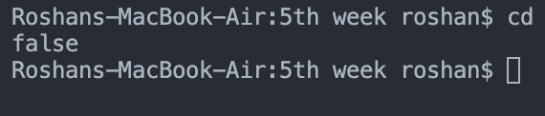

9. Write a Java code to copy the elements of an Array into another array.

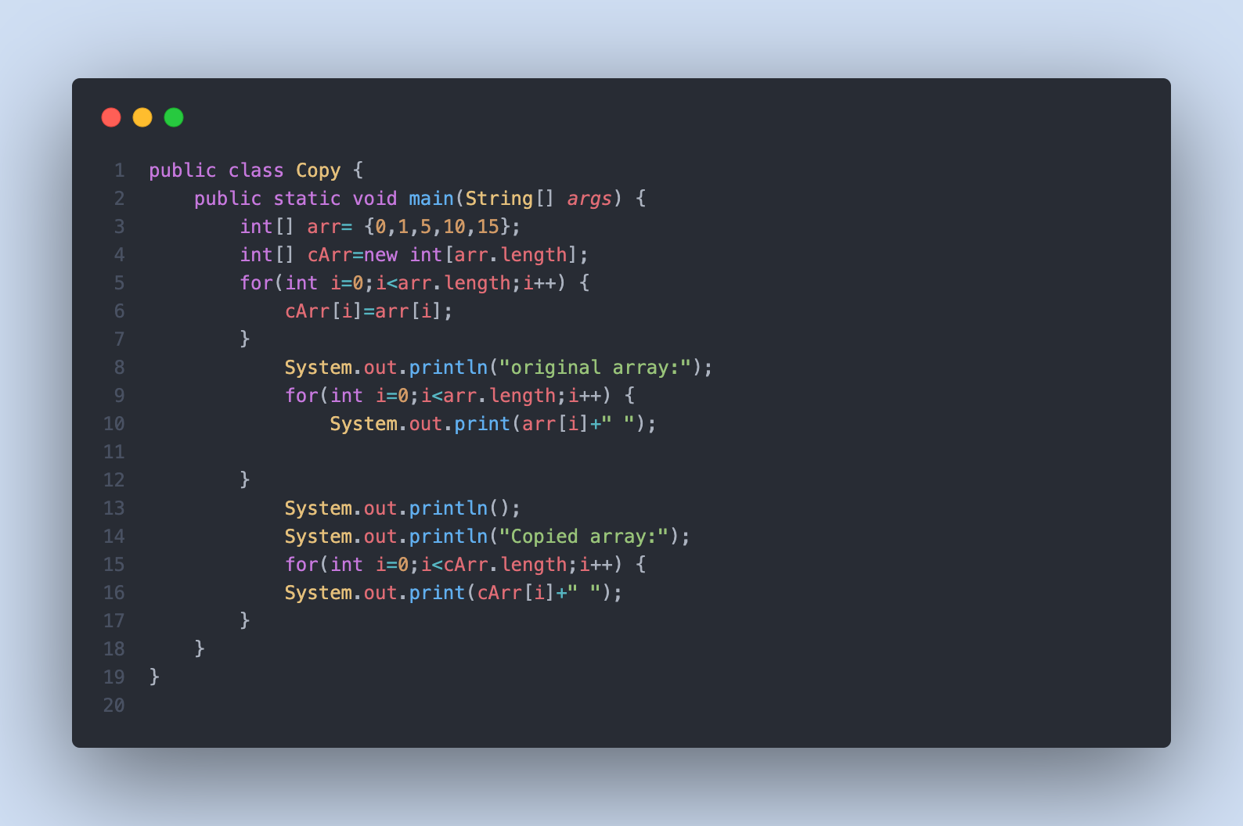

The output for the given program is:

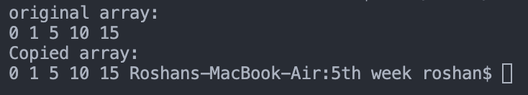

10. Write a java program to print the prime numbers found in an array with the index number. Arr = [10,12,17,19,25,85,96,56,11] You need to print the following: 17 - At index 2 19 - At index 3 11 - At index 8

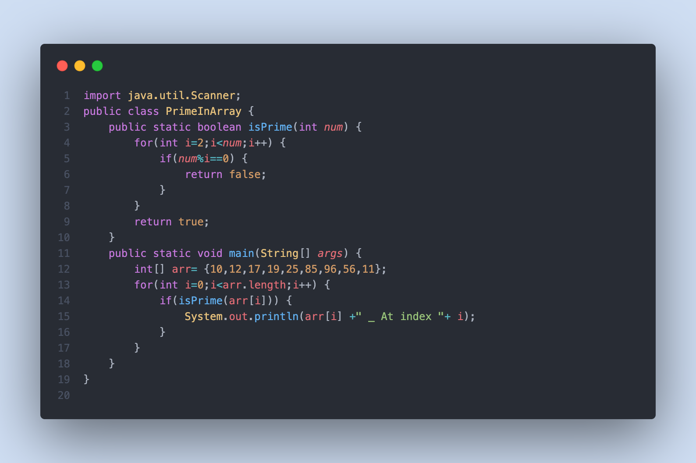

The output for the following program is:

